**Project Report Template**

**1 INTRODUCTION**

**1.1 Over view**

A CRM product owner has requested to create two applications, one is a sales app for sales reps to use this application and store customers data, and the second application is a service app for service reps/agents to provide support to customers in dealing cases. To generate business on top of the customers.

**1.2 Purpose**

Retail management optimizes internal processes such as inventory management, offline and online storefronts, warehouse operations, payment and accounting, and human resources. Retail management improves overall company cohesion. Retail store management improves customer experience and boosts customer satisfaction

**2 Problem Definition & Design Thinking**

**2.1 Empathy Map**

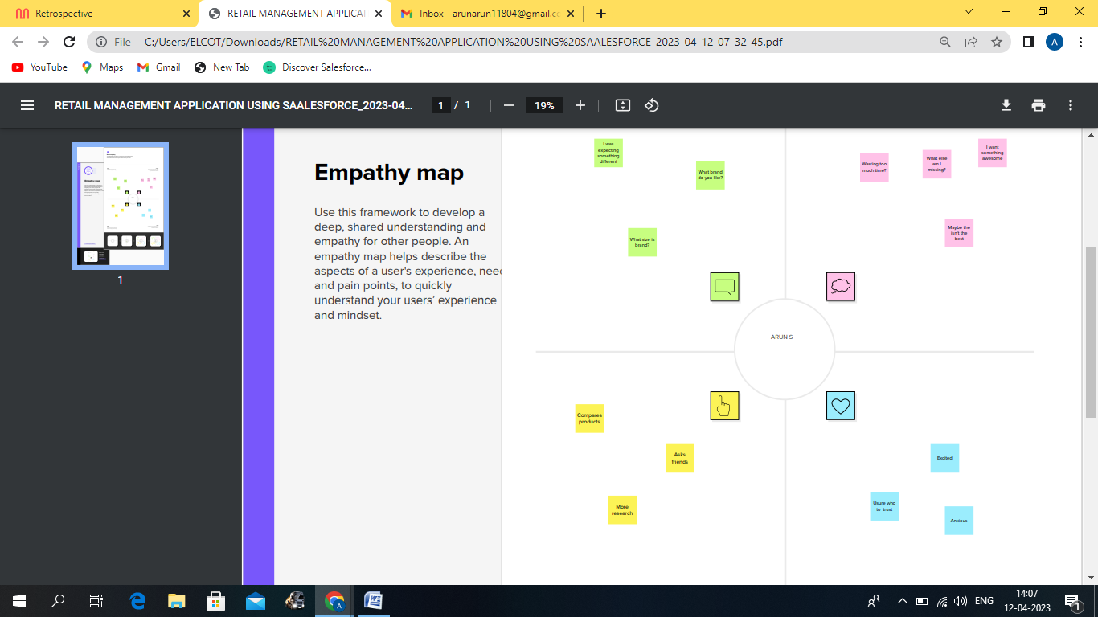

**2.2 Ideation & Brainstorming Map**

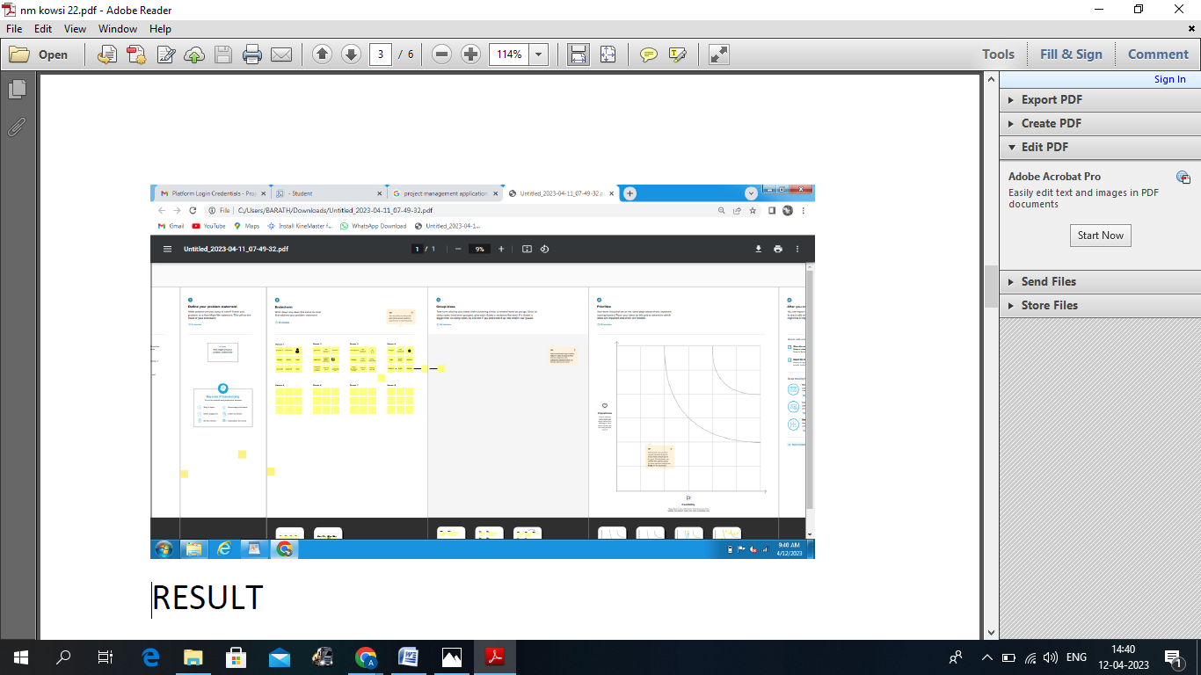

**3 RESULT**

**3.1 Data Model:**

|  |  |
| --- | --- |
|  |  |
| Obj 1:field label  Price  property | Currency  Master detail relationship |
| Obj 2:field label  Street address  Lead | Text area  Picklist |

**3.2 Activity & Screenshot**

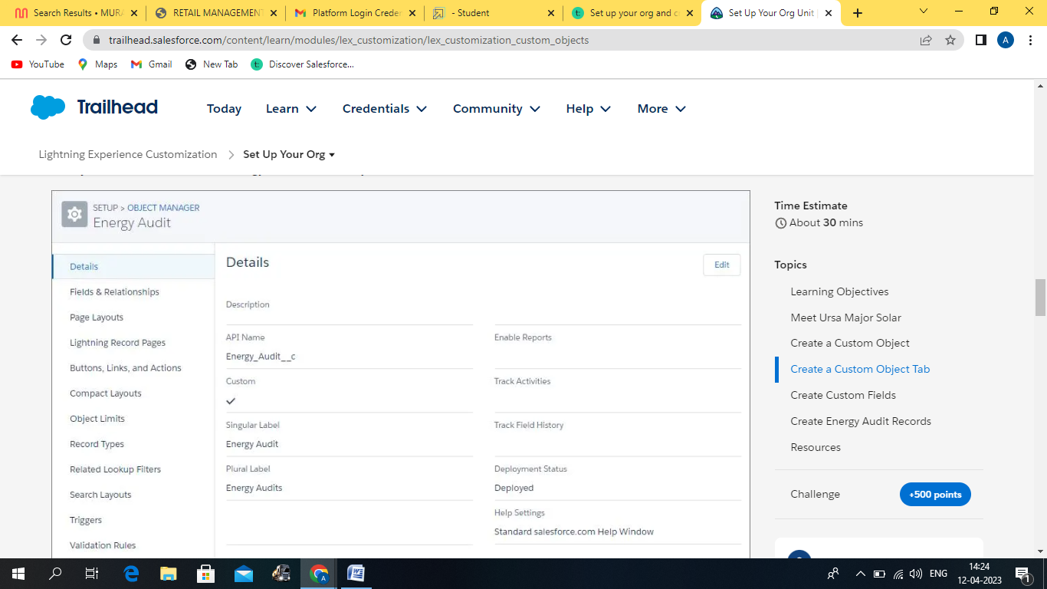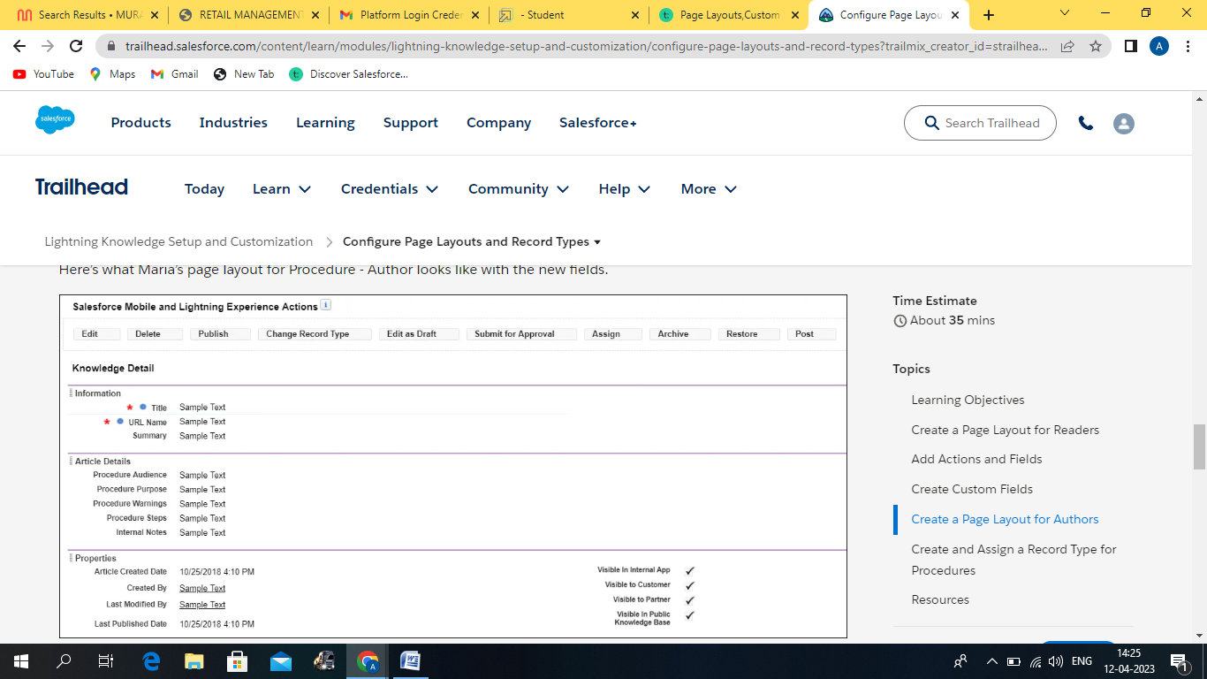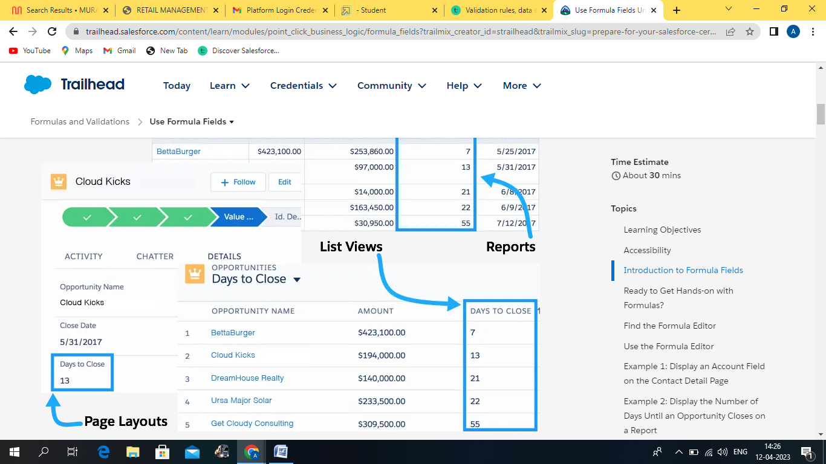

**Trailhead profile public URL**

Team lead- <https://trailblazer.me/id/aruns197>

Team member 1 – <https://trailblazer.me/id/nrollno06>

Team member 2 – <https://trailblazer.me/id/suresh121>

Team member 3 – <https://trailblazer.me/id/vijaychandran123>

**ADVANTAGES OF RETAIL MANAGEMENT**

Retail management software like [Retail POS](https://arirms.com/what-is-the-importance-of-retail-pos-software-for-businesses) runs 24-7 in multiple stores. Moreover, it collates all the data from inventory purchases to products sold via POS machines. It tracks all movements of products and flags any differences in the system. A user can virtually check all the available items in the warehouse or other stores. This helps managers make appropriate decisions in real-time.

**DIS ADVANTAGE OF RETAIL MANAGEMENT**

Retail giants have the advantage of enormous revenue figures. That allowsthem to sell items for less than smaller retailers, but at a cost to companies that deal with the retailer. Low-cost products at large retailers stem from several factors, including low shipping costs and price manipulation. A large retailer can essentially tell a manufacturer, "We'll buy your product at this price only." The price the retailer sets often results in a lower-than-average profit margin for the manufacturer, which enables the retailer to sell the product for less than smaller retailers. The manufacturer must then hope that it can sell the product in bulk to make up for the lower-than-usual profit margin. A failure to move large amounts of the product can result in diminishing profits

**APPLICATIONS**

A retail management system (RMS) is a platform that combines several modules to aid in the day-to-day operation of a retail store or chain, such as managing and buying inventory, checking out customers, scheduling employee shifts, keeping track of finances, etc.RMS can help retailers streamline all the processes of running a store, from procurement to sales and back-office activities such as accounting and human resources. Such an integrated platform provides a single source of truth for all retail data and can improve collaboration between various departments. Mobile versions of the software can be used while working in multiple locations such as stores or warehouses. All retail employees can use this tool, but it is most beneficial to managers and supervisors who need to plan and track operations across multiple business functions.

**Conclusion**

In this course we have explored the meaning of the terms retailing, marketing and marketing communications. We have also considered the importance of the marketing mix and identified the different communication tools that a retailer might use to interact and communicate with their target customers. You have been introduced to a few theoretical concepts and ideas, which have been illustrated using real world examples and cases in retailing.